dislike/ unlike : to dislike >> not to like/ unlike (prep): not similar to

**TO-infinitive or gerund: FORGET, REMEMBER, REGRET, GO ON, STOP, TRY**

*After these verbs, a to-infinitive refers to the future, while a gerund expresses an earlier action, relative to the time of the verb in the main clause:*

*Don't****forget to meet****Mr Moriarty at 10 o'clock this morning.* (You should meet Mr Moriarty at 10 o'clock this morning.)  
*I'll never****forget meeting****her for the first time.* (I'll never forget when I met her for the first time.)

*Did you****remember to buy****tea?* (Did you remember that you should buy tea?)  
*I don't****remember****ever****visiting****this museum.* (I don't remember that I have ever visited this museum.)

*We****regret to inform****you that your application has been rejected.* (We are sorry we have to inform you that your application has been rejected.)  
*I****regret spending****so much money last night.* (I am sorry that I spent so much money last night.)

*Whichever page you're on,****go on to read****the next chapter.* (Continue with the next chapter.)  
***Go on reading****the article.* (Continue reading the article.)

*We****stopped to drink****a cup of coffee.* (We stopped in order to drink a cup of coffee.)  
*I****stopped smoking****years ago.* (I gave up smoking years ago.)

*I****tried to reach****her at work, but the line was busy.* (I made an attempt to reach her at work.)  
*Why didn't you****try calling****her on her mobile?* (Why didn't you call her on her mobile to see if you could reach her?)

Discover/uncover: the first one, you didn’t look for it, the second you did look for it

Disinterested (I’m not involved)/ uninterested (I don’t care)

Discomfort (pain, mradh)/uncomfortable (adj)

Disable (to disable sth, to take away the ability of sth, a disabled person)/unable (cannot)

Disorganized (person)/ unorganized (place)

Non: non payment/ non-refundable **SOMETIMES YOU4LL FIND A HYPHNE! Check your dictionary**

In or Im? Im+b/m/p (just like French)

In/im can also mean “to go in” (migrate, immigrate), to cause or to intensify (to inflame)

Il + words that begin with L/ Ir with words that begin with R

Mis means “in a wrong way, wrongly” (to misappropriate) -> it isn’t truly a negative prefixe

Unsecure (not confident)/ insecure (not safe)

A+ consonant: Words that take ***a****–* as a negative prefix always begin with a [consonant](https://www.lawlessenglish.com/learn-english/pronunciation/consonants/). (apolitical, asexual, atheist)

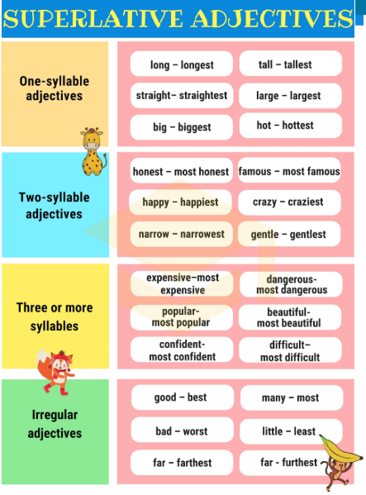

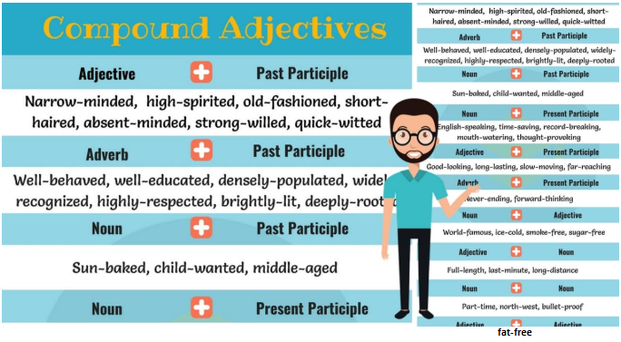

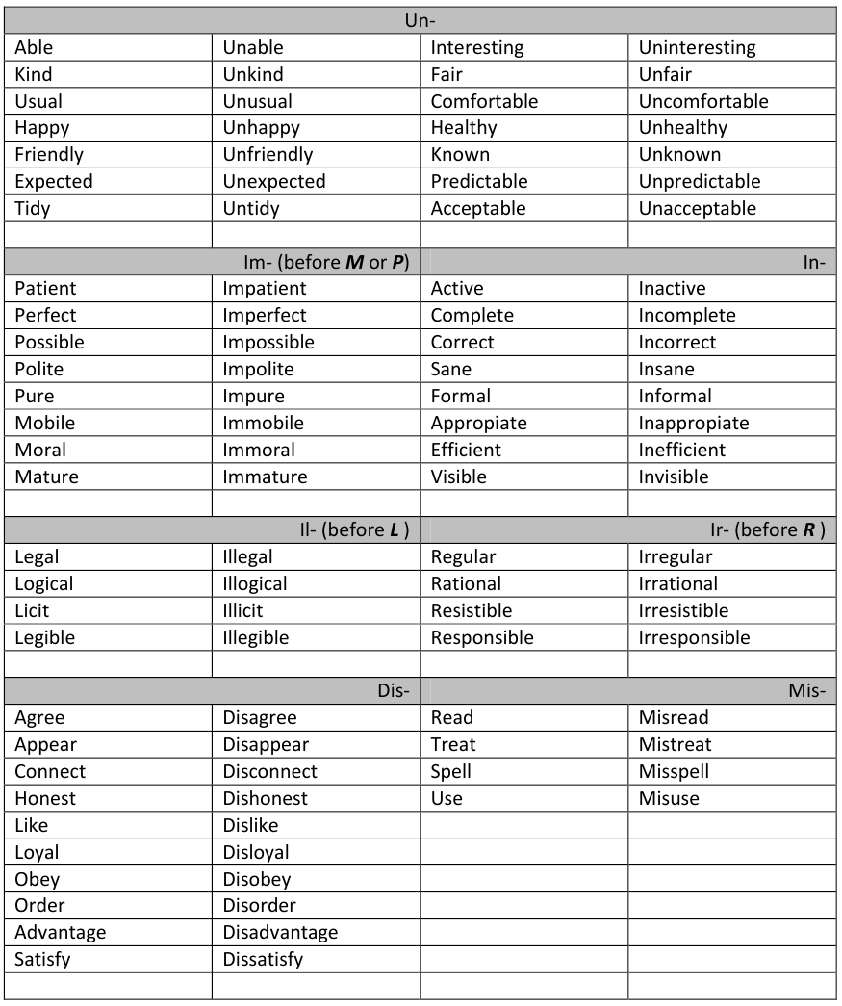

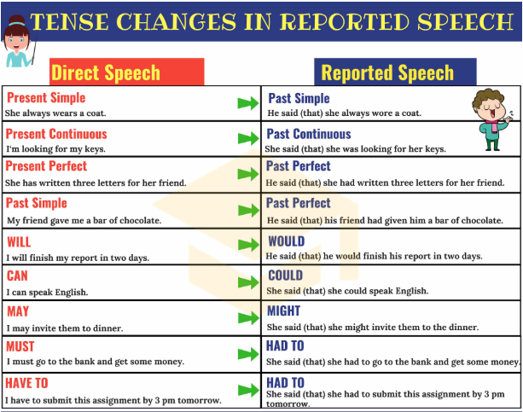

* ***Might*** (The verb remains unchanged)
* ***Should*** (The verb remains unchanged)

